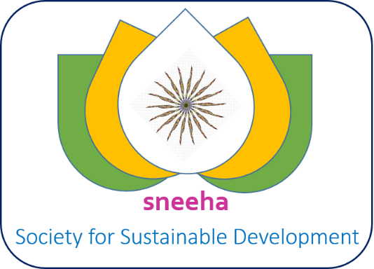

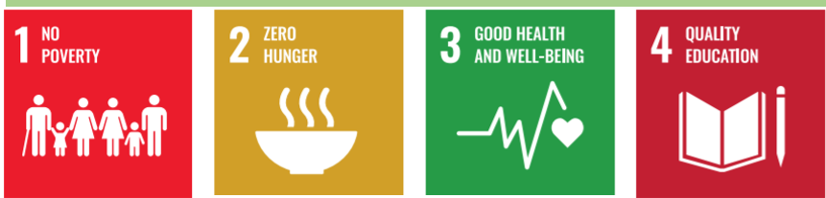

SNEEHA Society for Sustainable Development Membership Guide

Doc Ver | Modification | Prepared By | Last Upd | Approved By
0.1 | Initial Draft | SNEEHA SOCIETY FSD | 24.04.2025 | President

Sr.  # | SNEEHA SOCIETY FSD Executive Body Members | Position in SNEEHA | Contact No | Email
1 | SOCIETY MAIL |  | +91-1354143752,  +91-9821708385 | sneehasocietyfsd@gmail.com,  office@sneehafsd.org
2 | Dr. Shakti Bala Dutta | Member, President and Director,  Health and Nutrition | +91-9456501367 | presidentsneehafsd@gmail.com  president@sneehafsd.org
3 | Er. Surat Singh Kandari | Member and Vice President,  Agriculture, Animal Husbandry  and Waste Management | +91-8218747087  +919412910416 | vicepresident.sneehafsd@gmail.com  vicepresident@sneehafsd.org
4 | Rajesh Rawat | Member secretary | +91-9897074961 | secretary@sneehafsd.org
5 | Er. Heman Verma | Member and Joint Secretary | +91-8860162877 | jointsecretary@sneehafsd.org
6 | Supriya Chand | Member Treasurer and RTO | +91-7895236739 | treasurer@sneehafsd.org  rti@sneehafsd.org
7 | Mrs. Diptibala Mohanty | Member and Joint Director  Education and life skills  development | +91-9040002123 | diptibala@sneehafsd.org
8 | Ashis Dhyani | Member | +917895480337 | ashish@sneehafsd.org
9 | Nisha Kothiya | Member | +917060729628 | nisha@sneehafsd.org

Contents
1. About SNEEHA Society for Sustainable Development 3
2. Definition 3
3. Benefits of membership 3
4. Process for applying SNEEHA SOCIETYFSD Membership 3
5. Attachments needed along with the Membership application form 3
6. SNEEHA SOCIETY FSD Bank Account Details 4
7. General Rules 4
1. Membership Fees 4
Associate member – Rs. 1000.00 4
Member- Rs. 2000.00 4
Life Member- Rs. 10,000 4
2. To be eligible for the executive body(EB ), one must be a Life member or a member. Associate members are excluded from the EB 4
8. Rules to follow 5
9. Sample Membership card 5
10. Annexure A 6
11. Annexure B 6
Annexure B 7

1.0 About SNEEHA Society for Sustainable Development (SNEEHASFSD)

As per Vedic philosophy, the earth is given the status of a living mother. India’s Vedic philosophy has always emphasise the human connection with nature and ecological balance, and the need of people’s ethical treatment of nature for sustainable development. Since ancient times, Bharatvarsh (Undivided India) has been preaching to the world for sustainable development and practising a culture of worshipping nature and the environment. In the year 2015, the UN General Assembly formally adopted the 2030 Agenda for Sustainable Development, which guides global actions over the next 15 years. The agenda for sustainable development consists of 17 Sustainable Development Goals (SDGs) that focus on 5 themes viz. people, planet, prosperity, peace and partnership. One of the principles on which it focuses is ONE HEALTH, the health of plants, animals, the environment and humans.

SNEEHAFSD works in the areas of Health, Nutrition, Education, Environment, Ecology, Energy, Employment, Empowerment and Agriculture through Partnership to achieve sustainable development.

SNEEHA started in 2019 as a knowledge management forum of like-minded expert practitioners of public health, clinicians, medical educationists, nutritionists, immunization and vaccine management, energy experts, training experts, environmentalists, educationists, gender and women empowerment experts. After the 2018 Govt of India state-wise SDG baseline assessment report, this group decided to form a society and work at the ground level on a small scale to demonstrate a sustainable model.
- A voluntary society of thinkers and practitioners to bring change in India’s social and economic development sector
Facilitate and partner in Global and National Governmental as well as Non-Governmental initiatives for India to achieve SGDs through integrated, inter-sectoral and collaborative actions.SHEENA society for Sustainable development has been registered at Uttarakhand as a national society and will work primarily at Delhi, Uttarakhand, Uttar Pradesh, Odisha and West Bengal across India, gradually.

1.1.1 Action Areas and Scope

Health and Nutrition

Community and Public Health, with focus on Primary Health Care(PHC)

School Health, Immunisation, Public Health in Emergency

Adolescent Health, HIV and Maternal and Child Health issues

Mental Health, Geriatrics Health

Prevention of Non-communicable diseases (Cancer, Diabetes, Hypertension, Psychosomatic disease)

Environmental and Occupational Health

Health System strengthening, Health workforce capacity building, Health and EPI supply chain

Promotion of generic medicine and rationale drug use

Prevention of Antibiotic resistance

Support Poshan Abhiyan, PM’s overarching scheme for holistic nourishment

Facilitate the concept of -

Food to nutrition security,

Enhance the role of health services in nutrition

Decentralised approach to manage nutrition issues

Prevention of Malnutrition like SAM
B. Education
- Quality of education
- Early Childhood Development
- Life skill development
- Vocational education
- IT education
- Moral education
- Rural Education
- Education of illiterate people

C. Environment (Environment, Ecology and Energy)

Environmental pollution prevention and control (Water, Air, Noise, Chemical)

Water harvesting

Bio waste management and organic manure production

Afforestation

Promotion of sustainable and green energy like Solar, Biogas

Promotion of energy-efficient product and awareness generation

D. Agriculture (Agriculture, Floriculture, Fishery)

Promote homegrown nutritious food production

Soil health card

Crop diversification

Organic farming

Fishery

Herbal plantations

5. Tourism, Culture and Heritage

Community-driven eco-tourism

Local heritage preservation and documentation

Public awareness campaign

Cottage industry promotion and craft development

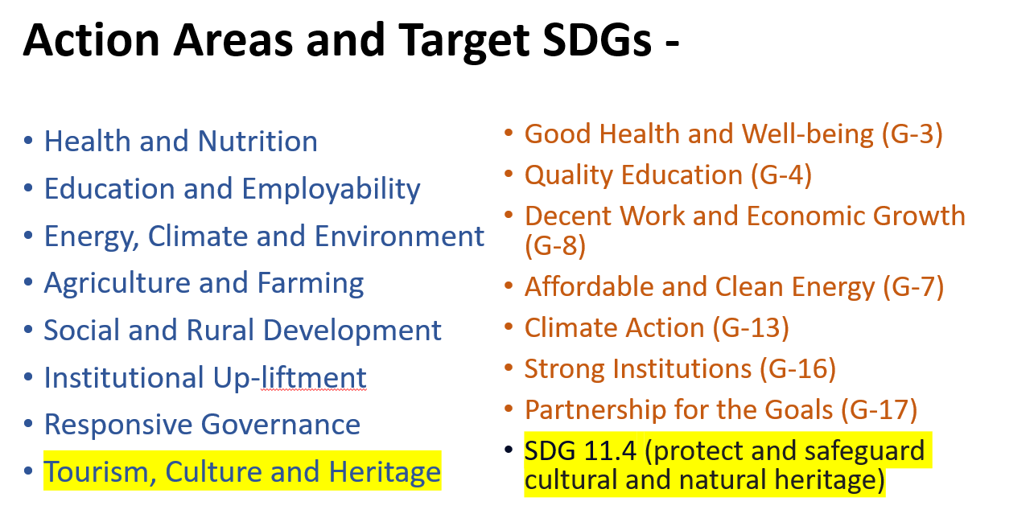

1.3 SNEEHA Organisational constituents

1.4. By law

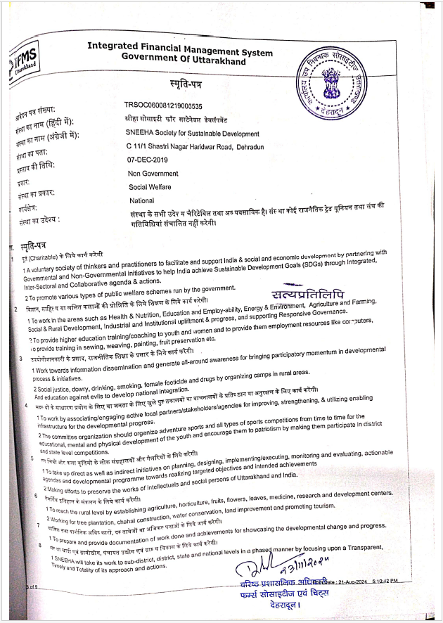

Definition

The SNEEHA SOCIETYFSD membership rule book defines the general rules for obtaining society membership, which is voluntary for each collaborator and partner (volunteers, advisers, other agencies, and associations).

Benefits of membership
  - By joining, you become an authorised member of SNEEHA Society FSD, which can later help you in certain matters and become your voice.
  - Any association is as strong as its members. So, all should take the membership.
  - You will officially become a part of choosing your association and can also participate in the EB membership( Member and Life member )
  - Members will have the entitlement to manage funding proposals of their speciality area, and will have privileges to manage their project funds and selection and management of project staff
  - Issue of membership card and certificate

Process for applying SNEEHA SOCIETYFSD Membership
Please follow the steps below.
  - Take the printout of the SNEEHA SOCIETY FSD membership Form (Given in Annexure B) or fill on a computer with clear details.
  - Attach your CV with your specialization and core area of expertise.
  - Fill the form in All CAPS
  - Provide your Photo ID and address proof ( Adhar and PAN )
  - It is desirable but mandatory to have a reference
  - Submit the Membership Fees in the SNEEHA SOCIETY FSD A/C (Details given in Sec --).
  - Fill in the bank payment details in the Application form.
  - Take the Print and sign it properly.
  - Submit it in the SNEEHA SOCIETYFSD office along with the attachment as given in Section 4 below.
  - If you are not submitting it physically in the office, send it a scanned copy/screenshot of payment and your other documents in the email: sneehasocietyfsd@gmail.com, info.sneehafsd@gmail.com
  - Once SNEEHA SOCIETYFSD verifies your details, you will receive membership within the next 10 days. In case of any delay, please contact your SNEEHA SOCIETYFSD office or AOA members.

Attachments needed along with the Membership application form

  - Copy of Address and Identity proof ( Adhar and PAN )
  - Bio Data with qualification, specialisation, areas of work experience, hobbies
  - Reference letter, if available

SNEEHA SOCIETY FSD Bank Account Details
Name: SNEEHA Society for Sustainable Development
Bank account no: 110233661940
Bank Name: CANARA BANK
IFSC Code : CNRB0002726
MICR Code: 248015006
SWIFT CODE: CNRBINBBBFD( For foreign exchanges )
Address: Sastrinagar, Haridwar Road, Dehradun, Uttarakhand, Pin 248001

QR Code :
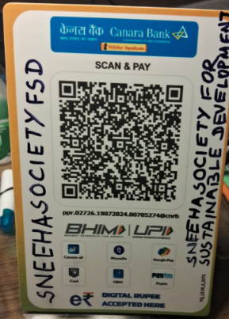

General Rules

Membership Fees

Associate member – Rs. 1000.00

Member- Rs. 2000.00

Life Member- Rs. 10,000

To be eligible for the executive body(EB ), one must be a Life member or a member. Associate members are excluded from the EB

Rules to follow
  - I will abide by the rules and regulations set forth by the society and any amendments made to them.
  - I will participate in society meetings and discussions to the best of my ability and cast my vote on matters that require member input.
  - I will promptly pay my membership dues and any other fees as required by the society.
  - I will not engage in activities that may cause harm, disruption, or discomfort to other members or the community at large.
  - I understand that any violation of the society's rules may lead to disciplinary action, which may include fines, warnings, or, in extreme cases, suspension or termination of my membership.

Sample Membership card

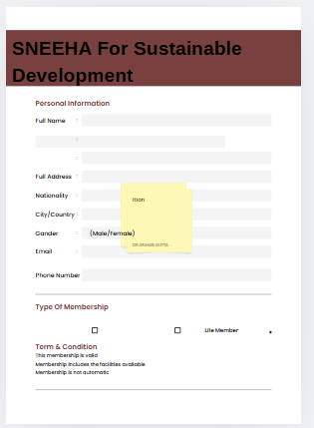

Annexure A

SNEEHA SOCIETYFSD will share the Byelaws copy in return for your membership Application request.

Annexure B

SNEEHA SOCIETYFSD Membership form is on the next page.

Annexure B

MEMBERSHIP FORM OF SNEEHA SOCIETY FSD

RGST No-UK06008112024013964, PAN No-CMAS8064M,
SNEEHA Society for Sustainable Development Secretariat Address: HN. No.11/C-Lane/ Street-1, Shastri Nagar, Haridwar- Road Dehradun, Uttarakhand, India: PIN 248001, Phone: +91-1354143752, +91-9821708385,+919456501367( President Sneeha)

Sr No. | Name of Member  (Write in Capital Letters) | Father’s/Spouse Name | Cell Number | Email Id | Signature
1

Communication Address:

City: State: - Pin:

Membership Fee Details

Cheque No/Cash/NEFT/IMPS:
Drawn on: Date: (DD / MM / YYYY)
Amount: Rs. 1000.00 ( Associate Member ), Rs. 2000.00 ( Member ) and Rs. 10,000 (Life Member )
I/We hereby undertake that above mentioned information is true in all aspects and my/our membership of SNEEHA SOCIETYFSD shall be effective from today, subject to the realization of the cheque within the admissible period. I/We also undertake and confirm above mentioned communication address and email id for any correspondence from SNEEHA SOCIETYFSD and shall ensure updating of my/our communication details in the record of SNEEHA SOCIETYFSD in case of any change in future. I/We also confirm that the above flat is free from any legal disputes among owners. I understand that by becoming a member of this society, I am subject to its rules, regulations, and bylaws, and I commit to follow them.
PS: Enclosed is a copy of the Government photo ID proof. and Bio Data Date: Place:

